Invited Speaker’s Summary CV
Invited Speaker’s Name* | Hsu, Wei-Hsiu 許維修
EDUCATIONAL BACKGROUND
Country* | Taiwan, R.O.C
Current Affiliation* | - School of Medicine, Chang Gung University, Tao-Yuan, Taiwan  - Sports Medicine Center, Chang Gung Memorial Hospital at Chia Yi, Chia Yi, Taiwan  - Department of Orthopedic Surgery, Chang Gung Memorial Hospital at Chia Yi, Chia Yi, Taiwan
Areas of Interest* | Sports medicine, Hyperbaric oxygen therapy, Joint reconstruction
Education | M.D. Ph. D
Post-Graduate Education* | - Sports Medicine and Arthroplasty, Department of Orthopedic Surgery Chang Gung Memorial Hospital, Linkou Medical Center  - Musculoskeletal research center, Department of orthopedic surgery & Bioengineering University of Pittsburgh, Medical center.
Academic Appointments* | - School of Medicine, Chang Gung University, Tao-Yuan, Taiwan
Professional Affiliations and  Scientific Publications* | Professional Affiliations  - American Academy of Orthopaedic Surgeons (AAOS)  - Orthopaedic Research Society (ORS)  - International Society of Arthroscopy, Knee Surgery, and Orthopedic Sports Medicine (ISAKOS)  - Undersea and Hyperbaric oxygen association, Republic of China  - Orthopaedic association, Taiwan  - Surgical association, Taiwan  - The Taiwan Osteoporosis association  - Joint Reconstructive Society  Scientific Publications  - Pei-An, Y., Fan, C. H., Kuo, L. T., Hsu, W. H.*, Chen, C. L., Peng, K. T., & Hsu, R. W. (2020). Differences in gait and muscle strength of patients with acute and chronic anterior cruciate ligament injury. Clin Biomech (Bristol, Avon), 80, 105161.  - Yu, P. A., Hsu, Hsu, W. H.* W. B., Kuo, L. T., Lin, Z. R., Shen, W. J., & Hsu, R. W. (2019). The effects of high impact exercise intervention on bone mineral density, physical fitness, and quality of life in postmenopausal women with osteopenia: A retrospective cohort study. Medicine (Baltimore), 98(11), e14898.  - Hsu, W. H.*, Hsu, W. B., Shen, W. J., Lin, Z. R., Chang, S. H., & Hsu, R. W. (2019). Twenty-four-week hospital-based progressive resistance training on functional recovery in female patients post total knee arthroplasty. Knee, 26(3), 729-736.  - Hsu, W. H.*, Yu, P. A., Lai, L. J., Chen, C. L., Kuo, L. T., & Fan, C. H. (2018). Effect of Extracorporeal Shockwave Therapy on Passive Ankle Stiffness in Patients With Plantar Fasciopathy. J Foot Ankle Surg, 57(1), 15-18.  - Hsu, W. H.*, Fan, C. H., Yu, P. A., Chen, C. L., Kuo, L. T., & Hsu, R. W. (2018). Effect of high body mass index on knee muscle strength and function after anterior cruciate ligament reconstruction using hamstring tendon autografts. BMC Musculoskelet Disord, 19(1), 363.  - Hsu, W. B., Hsu, W. H.*, Hung, J. S., Shen, W. J., & Hsu, R. W. (2018). Transcriptome analysis of osteoblasts in an ovariectomized mouse model in response to physical exercise. Bone Joint Res, 7(11), 601-608.

Invited Speaker’s Summary CV
Invited Speaker’s Name* | Kuo Chun En
EDUCATIONAL BACKGROUND
Country* | Taiwan
Current Affiliation* | Acupuncture Division, Chinese Medicine Department, Kaohsiung Chang Gung Memorial Hospital, Kaohsiung, Taiwan
Areas of Interest* | Sports medicine, Acupuncture, Pain management, TCM, Natural products.
Education | 2011/06 Bachelor Degree of Chinese Medicine Department, China Medical University, Taichung, Taiwan
Post-Graduate Education* | 2017/08 M.S. in Department of Medical Laboratory Science and Biotechnology, Kaohsiung Medical University, Kaohsiung, Taiwan
Academic Appointments* | Lecturer of Meiho University, Pintung, Taiwan.  Assistant Professor of Meiho University, Pintung, Taiwan.
Professional Affiliations and  Scientific Publications* | Director of Taiwan TCM Medical Association.  Member of Taiwan Chinese Medicine Dermatology Society, Chinese Medical Association of Acupuncture, Taiwan Clinical Chinese Medicine Association, and Taiwan Association of Chinese Medicine and Pharmacy Quality.  - Lin C-H, Wu S-Y, Hu W-L, Hung C-H, Hung Y-C, Aurea Kuo C-E*. Laser acupuncture for refractory coccydynia after traumatic coccyx fracture: A case report. Medicine. 2020;99(6):e18860. (SCI; IF=1.870)  - Szu-Ying Wu, Chien-Hung Lin, Nai-Jen Chang, Wen-Long Hu, Yu-Chiang Hung, Yu Tsao, Chun-En Aurea Kuo∗. Combined effect of laser acupuncture and electroacupuncture in knee osteoarthritis patients: A protocol for a randomized controlled trial. Medicine. 2020;99(12):e19541. doi: 10.1097/MD.0000000000019541. (SCI; IF=1.870)  - Chun-En Aurea Kuoa,b,*, Szu-Ying Wua,b,c,d, Chen-Hsiang Leee, Yun-Ru Laif,g, Cheng-Hsien Luf,g,h, Po-Cheng Cheni, Jai-Hong Chengj,k, Li-Yu Tsail, Ke-Tien Yenm, Yu Tsaom,n, Shih-Meng Tsaio,** "Toona sinensis modulates autophagy and cytokines in lipopolysaccharide-induced RAW 264.7 macrophages." Biomedicine & Pharmacotherapy 129 (2020): 110386. (SCI; IF=4.545)

Invited Speaker’s Summary CV
Invited Speaker’s Name* | Wu Szu Ying
EDUCATIONAL BACKGROUND
Country* | Taiwan
Current Affiliation* | Orthopedics and Traumatology Division, Chinese Medicine Department, Kaohsiung Chang Gung Memorial Hospital, Kaohsiung, Taiwan
Areas of Interest* | Sports medicine, Pain management, Acupuncture, Laser Acupuncture
Education | 2012/06 Bachelor Degree of Chinese Medicine Department, Chang Gung University, Taoyuan, Taiwan
Post-Graduate Education* | 2020/06 M.S. in Department of Sports Medicine, Kaohsiung Medical University, Kaohsiung, Taiwan
Academic Appointments* | Lecturer of Meiho University, Pintung, Taiwan.
Professional Affiliations and  Scientific Publications* | - Director of Taiwan Association of Chinese Medicine and Pharmacy Quality  - Director of Taiwan Anti-Doping Association  - Chief secretary of Taiwan Traditional Chinese Medicine Medical Association  - Member of Chinese Medical Association of Acupuncture  Publications  - Kuo CE*, Wu SY, Lee CH, Lai YR, Lu CH, Chen PC, ... & Tsai SM. Toona sinensis modulates autophagy and cytokines in lipopolysaccharide-induced RAW 264.7 macrophages. Biomedicine & Pharmacotherapy. 2020; 129: 110386.  - Wu SY, Lin CH, Chang NJ, Hu WL, Hung YC, Tsao Y, Aurea Kuo CE. Combined effect of laser acupuncture and electroacupuncture in knee osteoarthritis patients: A protocol for a randomized controlled trial. Medicine. 2020; 99(12), e19541.  - Lin CH, Wu SY, Hu WL, Hung CH, Hung YC, Aurea Kuo CE*. Laser acupuncture for refractory coccydynia after traumatic coccyx fracture: A case report. Medicine. 2020;99(6):e18860.  - Hu WL, Tsai MC, Kuo CE, Liu CT, Wu SY, Wu TC, Hung YC*. Adjuvant laser meridian massage in men with opioid use disorder on methadone maintenance treatment: Protocol for a case-controlled study. Medicine, 2019, 98(39)  - Wu SY, Lu CN, Chung CJ, Kuo CE, Sheen JM, Hsueh TP, Chen CC, Bi KW*. Therapeutic effects of acupuncture plus fire needle versus acupuncture alone in lateral epicondylitis: A randomized case–control pilot study. Medicine, 2019, 98.22: e15937.  - Wu TC, Wu SY, Hu WL, Kuo CE*. Laser Acupuncture for Metatarsalgia: A Case Report. J Chin Med, 2018, 29(1): 60-74

Invited Speaker’s Summary CV
Invited Speaker’s Name* | Ting-Chung Wang | 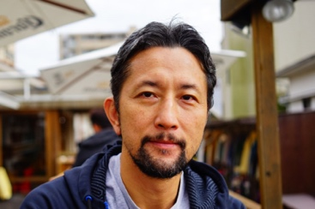
EDUCATIONAL BACKGROUND：
Country* | Taiwan, R.O.C
Current Affiliation* | - School of Medicine, Chang Gung University, Tao-Yuan, Taiwan  - Division of Neurosurgery, Department of Surgery, Chang Gung Memorial Hospital, Chiayi, Taiwan
Areas of Interest* | Cerebrovascular disease, neuro-oncology, complex spine disorders, neurophysiology, and molecular studies in the field of neuro-oncology.
Education | Chang Gung University, M.D. Ph. D
Post-Graduate Education* | Graduate Institute of Clinical Medical Sciences, College of Medicine, Chang Gung University, Taoyuan, Taiwan
Academic Appointments* | - Assistant Professor, School of Medicine, Chang Gung University, Tao-Yuan, Taiwan
Professional Affiliations and  Scientific Publications* | 1.Wang TC, Luo SJ, Lin CL, Chang PJ, Chen MF. Chen*.  "Modulation of p75 neurotrophin receptor under hypoxic conditions induces migration and invasion of C6 glioma cells". Clin Exp Metastasis. 2015 Jan;32(1):73-81.  2.Wang TC, Cheng CY, Yang WH, Chen WC, Chang PJ*.  Characterization of the highly proliferative secondary tumor clusters along host blood Mol Med Rep. 2015Aug18.  3.Lee JD. Hsiao KM, Wang TC, Lee TH, Kuo YW, Huang YC, Hsu HL, Lin YH, Wu CY, Huang YC, Lee M, Yang HT, Hsu CY, Pan YT .  Mutual effect of rs688 and rs5925 in regulating low-density lipoprotein receptor splicing. DNA Cell Biol. 2014 Dec;33(12):869-75.  4.Lin CH, Lee MH, Lin MH, Wang TC, Cheng WC, Tsai YH, Hsu CH, Yang JT. Percutaneous dorsal root ganglion lysis with phenol for the treatment of pain associated with thoracic compression fracture. Acta Neurochir (Wien). 2013 Dec; 155 (12):2313-20  5.Lee MH, Lin MH, Weng HH, Cheng WC, Tsai YH, Wang TC, Yang JT.Feasibility of Intra-operative Computed Tomography Navigation System for Pedicle Screw Insertion of the Thoraco-lumbar Spine. J Spinal Disord Tech. 2012 Dec 3.

Invited Speaker’s Summary CV
Invited Speaker’s Name* | Liang-Tseng Kuo, M.D. | 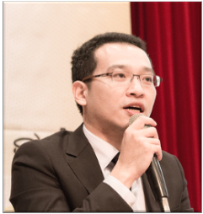
EDUCATIONAL BACKGROUND
Country* | Taiwan, Republic of China
Current Affiliation* | Director, Division of Sports Medicine, Department of Orthopaedic Surgery, Chang Gung Memorial Hospital, Chiayi and College of Medicine, Chang Gung University, Taiwan
Areas of Interest* | Shoulder surgery, Sports Medicine, Traumatology
Education | Chang Gung University
Post-Graduate Education* | - Orthopedic Surgery: Orthopedic Resident in Chang Gung Memorial Hospital, Chiayi, Taiwan  - Sports Medicine and Shoulder Fellow: Samsung Medical Center, Seoul, Korea
Academic Appointments* | Associate Professor, Chang Gung Memorial Hospital, Chiayi, Taiwan
Professional Affiliations and  Scientific Publications* | Professional Affiliations：  Taiwan Orthopaedic Association, ROC  Taiwan Evidence Based-Medicine Association, executive council member  Taiwan Osteoporosis Association, ROC  Scientific Publications* (first author and correspondence in last 3 year)  - Kim DK, Park G, Kuo LT*, Park WH. Association of Vitamin D Status with Lower Limb Muscle Strength in Professional Basketball Players: A Cross-Sectional Study. Nutrients. 2020 Sep 5;12(9).  - Kim DK, Park G, Kuo LT*, Park WH. Isokinetic Performance of Shoulder External and Internal Rotators of Professional Volleyball Athletes by Different Positions. Sci Rep. 2020;10(1):8706.  - Tan CW, Hsu WH, Yu PA, Chen CL, Kuo LT*, Chi CC, Kim D, Park G. Anterior Cruciate Ligament Reconstruction in Patients Older Than 50 Years: A Systematic Review and Meta-analysis. Orthop J Sports Med. 2020;8(4):2325967120915698.  - Kuo LT, Chen HM, Yu PA, Chen CL, Hsu WH, Tsai YH, Chen KJ, Chen VC. Depression increases the risk of rotator cuff tear and rotator cuff repair surgery: A nationwide population-based study. PLoS One. 2019;14(11):e0225778.  - Kim DK, Park G, Kuo LT*, Park WH. The Relationship between Vitamin D Status and Rotator Cuff Muscle Strength in Professional Volleyball Athletes. Nutrients. 2019;11(11).  - Huang PH, Chen TH, Lin YS, Lin SJ, Kuo LT*, Chen CL, Yu PA, Hsu WH. Chronic Kidney Disease Worsens Health Outcomes in Diabetic Patients After Hip Fracture Surgery: An Asian Nationwide Population-Based Cohort Study. J Bone Miner Res. 2019;34(5):849-858.  - Kim DK, Park G, Kuo LT*, Park WH. Patients older than 50 years had similar results of knee strength and anteroposterior stability after ACL reconstruction compared to younger patients. Knee Surg Sports Traumatol Arthrosc. 2019;27(1):230-238.  - Kuo LT, Chen CL, Yu PA, Hsu WH, Chi CC, Yoo JC. Epinephrine in irrigation fluid for visual clarity in arthroscopic shoulder surgery: a systematic review and meta-analysis. Int Orthop. 2018;42(12):2881-2889.  - Kim D, Park G, Kuo LT*, Park W. The effects of pain on quadriceps strength, joint proprioception and dynamic balance among women aged 65 to 75 years with knee osteoarthritis. BMC Geriatr. 2018;18(1):245.  - Kim DK, Park G, Kadir KBHMS, Kuo LT*, Park WH. Comparison of Knee Stability, Strength Deficits, and Functional Score in Primary and Revision Anterior Cruciate Ligament Reconstructed Knees. Sci Rep. 2018;8(1):9186.  - Kuo LT, Yu PA, Chen CL, Hsu WH, Chi CC. Tourniquet use in arthroscopic anterior cruciate ligament reconstruction: a systematic review and meta-analysis of randomised controlled trials. BMC Musculoskelet Disord. 2017;18(1):358.

Invited Speaker’s Summary CV
Invited Speaker’s Name* | Chang, Shih-Chieh
EDUCATIONAL BACKGROUND
Country* | Taiwan
Current Affiliation* | Tucheng Hospital, Chang Gung Medical Foundation
Areas of Interest* | Exercise Physiology, Cardiopulmonary Rehabilitation.
Education | School of Medicine, Class 2014, Chung Shan Medical University
Post-Graduate Education* | N/A
Academic Appointments* | Attending Physician, Department of Physical Medicine & Rehabilitation.
Professional Affiliations and  Scientific Publications* | Chang, S. C., Adami, A., Lin, H. C., Lin, Y. C., Chen, C., Fu, T. C., Hsu, C. C., & Huang, S. C. (2020). Relationship between maximal incremental and high-intensity interval exercise performance in elite athletes. PloS one, 15(5), e0226313.  Huang, S. C., Liu, K. C., Wong, A., Chang, S. C., & Wang, J. S. (2018). Cardiovascular Autonomic Response to Orthostatic Stress Under Hypoxia in Patients with Spinal Cord Injury. High altitude medicine & biology, 19(2), 201–207.  Chen, P. Y., Chang, S. C., Anne Chao, Yeh, Y. C., & Chan, W. S. (2018). Locked-in-Like Syndrome Developed After Infusion of Lidocaine in A Patient With Myasthenia Gravis. Resuscitation & Intensive Care Med 2018;3:81-85  Tsai, W.C., Liang, F.C, Cheng, J.W., Lin, L.P., Chang S.C., Chen, H.H., Pang, J.H., “High glucose concentration up-regulates the expression of matrix metalloproteinase-9 and -13 in tendon cells,” BMC Musculoskeletal Disorders 2013, 14:255
Invited Speaker’s Summary CV
Invited Speaker’s Name* | Chen, Chien-Hung | 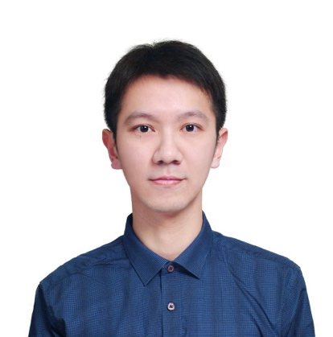
EDUCATIONAL BACKGROUND
Country* | Taiwan
Current Affiliation* | Chang Gung Memorial Hospital, Taoyuan  Department of Physical Medicine & Rehabilitation
Areas of Interest* | Rehabilitation medicine, sports medicine
Education | Chang Gung University, Department of Medicine
Post-Graduate Education* | Graduate Institute of Clinical Medical Sciences, Chang Gung University
Academic Appointments*

Professional Affiliations and  Scientific Publications* | - Member of Taiwan Academy of Physical Medicine & Rehabilitation  - Member of Sports Medicine Association, R.O.C.  - Member of the Society of Ultrasound in Medicine of the R.O.C.

Invited Speaker’s Summary CV
Invited Speaker’s Name* | Yin-Chou Lin | 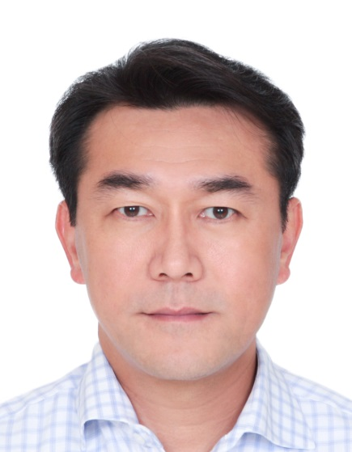
EDUCATIONAL BACKGROUND
Country | Taiwan, Republic of China
Current Affiliation | Chang Gung Memorial Hospital, Taoyuan  Department of Physical Medicine & Rehabilitation
Areas of Interest | Exercise physiology, sports medicine, musculoskeletal ultrasound, physical medicine
Education | 2003/09-2011/07 National Taiwan Normal University
Post-Graduate Education
Academic Appointments | 2018– till now member of Chinese Taipei Olympic Committee  2019– till now Chairman of TASM
Professional Affiliations and  Scientific Publications | - Fei-Ying Cheng, Mei-Jy Jeng, Yin-Chou Lin, Shih-Hao Wang*, Shih-Hao Wu,Wen-Cheng Li, Kuo-Feng Huang, Te-Fa Chiu. Incidence and severity of acute mountain sickness and associated symptoms in children trekking on Xue Mountain, Taiwan. PLoS ONE.2017 August 23;12(8):e0183207 DOI: 10.1371/journal.pone.0183207. eCollection 2017.  - Chin-Man Wang*, Yi-Chou Wang, Yin-Chou Lin, Yu-Wei Hu1, Ji-Yih Chen. Acute Cerebrovascular Accidents Secondary to Internal Carotid Artery Thrombosis in Severe Ovarian Hyperstimulation Syndrome (OHSS). Ann Clin Case Rep. 2017; 2: 1362.  - Yin-Chou Lin, Wen-Chuin Hsu, Chien-Hung Chen, Chai-Wei Wang, Katie Pei-Hsuan Wu, Alice M. K. Wong. Simplified Tai Chi 6-Form Apparatus for Balance in Elderly People with Alzheimer's Disease. Journal of Medical and Biological Engineering. 2018 Oct 25(4)：1-11 DOI：10.1007/s40846-018-0451-5  - Chih-Kuang Chen,Tsai-Hsuan Tsai, Yin-Chou Lin, Chung-Chih Lin, Su-Chu Hsu, Chia-Ying Chung, Yu-Cheng Pei, Alice M. K. Wong. Acceptance of different design exergames in elders. PLoS ONE. 2018 Jul 5;13(7):1-22. DOI: 10.1371/journal.pone.0200185  - Jian-Hong Chen, Po-Hsin Tsai, Yin-Chou Lin, Chih-Ken Chen, Ching-Yen Chen. Mindfulness training enhances flow state and mental health among baseball players in Taiwan. Psychol Res Behav Manag. 2019; 12: 15–21. DOI：10.2147/PRBM.S188734  - Chih-Kuang Chen, Yin-Chou Lin, Ju-Wen Cheng, Yu-Cheng Pei, Geng-Hao Liu, Yen-Lung Chen, Alice M. K. Wong. Effectiveness of Laser Acupuncture in Alleviating Chronic Insomnia: A Single-Blinded Randomized Controlled Trial. Evidence-Based Complementary and Alternative Medicine. 2019(5):1-9. DOI：10.1155/2019/8136967  - Szu-Heng Wang,Tung-Yang Yu, Yin-Chou Lin, Pei-Chi Liao, Wen-Chung Tsai. Deformation of coracoacromial ligament during overhead movement as an early indicator of subacromial impingement in elite adolescent badminton players.Physician and Sportsmedicine. 2019 May 47：427-432 DOI：10.1080/00913847.2019.1613095  - Chun-Chieh Chao, Lung Hung Chen, Yin-Chou Lin, Shih-Hao Wang, Shih-Hao Wu, Wen-Cheng Li, Kuo-Feng Huang, Te-Fa Chiu, I-Chih Kuo. Impact of a 3-Day High-Altitude Trek on Xue Mountain (3886 m), Taiwan, on the Emotional States of Children: A Prospective Observational Study.High Alt Med Biol. 2019 Mar;20(1):28-34. DOI: 10.1089/ham.2018.0086

Invited Speaker’s Summary CV
Invited Speaker’s Name* | Jian-Hong Chen | 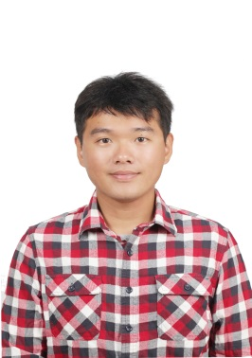
EDUCATIONAL BACKGROUND
Country* | Taiwan
Current Affiliation* | Department of psychiatry, Chang Gung Memorial hospital at Keelung
Areas of Interest* | Mindfulness, Sports psychology, Psychiatry
Education | Chang Gung University, the School of Medicine
Post-Graduate Education*

Academic Appointments*

Professional Affiliations and  Scientific Publications* | Chen, J. H., Tsai, P. H., Lin, Y. C., Chen, C. K., & Chen, C. Y. (2019). Mindfulness training enhances flow state and mental health among baseball players in Taiwan. Psychology research and behavior management, 12, 15.

Invited Speaker’s Summary CV
Invited Speaker’s Name* | Yu, Pei-An M.D. 余培安 | 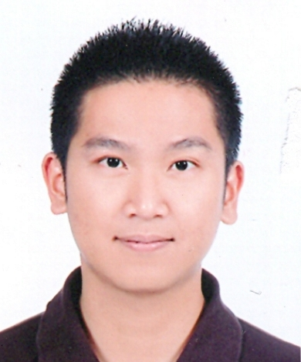
EDUCATIONAL BACKGROUND
Country* | Taiwan, R.O.C
Current Affiliation* | - Sports Medicine Center, Chang Gung Memorial Hospital at Chia Yi, Chia Yi, Taiwan  - Department of Orthopedic Surgery, Chang Gung Memorial Hospital at Chia Yi, Chia Yi, Taiwan
Areas of Interest* | Sports medicine, Hyperbaric oxygen therapy, Joint reconstruction
Education | Chang Gung University
Post-Graduate Education* | - Sports Medicine and Arthroplasty, Department of Orthopedic Surgery Chang Gung Memorial Hospital, Linkou Medical Center
Academic Appointments* | - Assistant Professor, Chang Gung Memorial Hospital
Professional Affiliations and  Scientific Publications* | Professional Affiliations  - Undersea and Hyperbaric oxygen association, Republic of China  - Orthopaedic association, Taiwan  Scientific Publications  - Pei-An, Y., Fan, C. H., Kuo, L. T., Hsu, W. H., Chen, C. L., Peng, K. T., & Hsu, R. W. (2020). Differences in gait and muscle strength of patients with acute and chronic anterior cruciate ligament injury. Clin Biomech (Bristol, Avon), 80, 105161.  - Pei-An, Y., Hsu, Hsu, W. H., W. B., Kuo, L. T., Lin, Z. R., Shen, W. J., & Hsu, R. W. (2019). The effects of high impact exercise intervention on bone mineral density, physical fitness, and quality of life in postmenopausal women with osteopenia: A retrospective cohort study. Medicine (Baltimore), 98(11), e14898.  - Hsu, W. H., Yu, P. A., Lai, L. J., Chen, C. L., Kuo, L. T., & Fan, C. H. (2018). Effect of Extracorporeal Shockwave Therapy on Passive Ankle Stiffness in Patients With Plantar Fasciopathy. J Foot Ankle Surg, 57(1), 15-18.  - Hsu, W. H., Fan, C. H., Yu, P. A., Chen, C. L., Kuo, L. T., & Hsu, R. W. (2018). Effect of high body mass index on knee muscle strength and function after anterior cruciate ligament reconstruction using hamstring tendon autografts. BMC Musculoskelet Disord, 19(1), 363.

Invited Speaker’s Name* | Chih-Hao Chiu 邱致皓 | 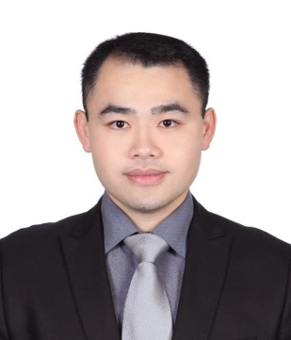
EDUCATIONAL BACKGROUND
Country* | Taiwan
Current Affiliation* | Department of Orthopedic Surgery, Division of Sports Medicine, Chang Gung Memorial Hospital, Taiwan
Areas of Interest* | - Orthopedic Sports Medicine  - Arthroscopic surgery
Education | 1998/09-2005/06 Chang-Gung University
Post-Graduate Education* | 2018/08/01 to 2019/07/31 Fellowship, Hospital de La Tour, Switzerland  2011/07/01~ Attending Physian, Division of Sports Medicine, Taoyuan Branch of Orthopaedic Department Chang Gung Memorial Hospital Taipei-Linkou Medical Center  2010/07/01~2011/06/30 Fellowship of Department of Othopedic Sports Medicine, Chang Gung Memorial Hospital Taipei-Linkou Medical Center  2006/09/01~2010/06/30, Resident, Orthopaedic Department Chang Gung Memorial Hospital Taipei-Linkou Medical Center  2005/09/01~2006/08/31, Resident, Surgical Department Chang-Gung Memorial Hospital Chia-Yi Department

Invited Speaker’s Summary CV
Invited Speaker’s Name* | Wen-Yi, Chou (周文毅) | 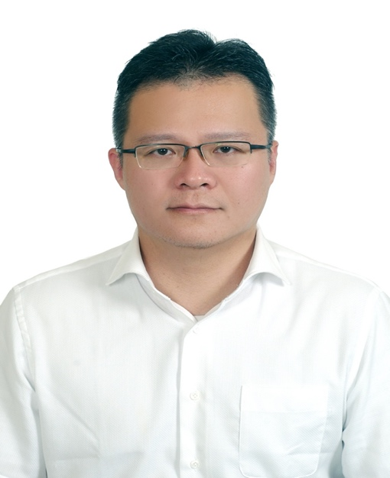
EDUCATIONAL BACKGROUND
Country* | Taiwan, R.O.C
Current Affiliation* | Chang Gung Memorial Hospital, Kaohsiun
Areas of Interest* | Orthopaedic Surgery, Orthopaedic Sports medicine, Extracorporeal shockwave therapy
Education | Bachelor, Kaohsiung Medical University, Kaohsiung
Post-Graduate Education* | nil
Academic Appointments* | Associate Professor, Department of Orthopaedic Surgery,  Kaohsiung Chang Gung Memorial Hospital
Professional Affiliations and  Scientific Publications* | 1.Shockwave therapy improves anterior cruciate ligament reconstruction.Wang CJ, Ko JY, Chou WY, Hsu SL, Ko SF, Huang CC, Chang HW. J Surgical Res 2014;188:110-8.  2. ESWT and alendronate sodium demonstrate equal protective effects in osteoarthritis of the knee. Wang CJ, Chou WY, Hsu SL, Huang CY, Cheng JH. Shock Waves 2016;26:53-62 (SCI; IF=1.424; Mechanics 95/134)  3.Changes of articular cartilage and subchondral bone after. extracorporeal shockwave therapy in osteoarthritis of the knee  Wang CJ, Cheng JH, Chou WY, Hsu SL, Chen JH, Huang CY. Int J. Med Sci 2017;14:213-223. (SCI; IF=2.333; Medicine, General & Internal 53/160)  4. Short-term clinical results of intra-articular PRP injections for early osteoarthritis of. Knee. Huang PH, Wang CJ, Chou WY, Wang JW, Ko JY. International Journal of Surgery May 2017;42:117-22. (SCI; IF=3.158; Surgery 40/203)  5.Evaluating posterior cruciate ligament injury by using two-dimensional ultrasonography and sonoelastography. Wang LY, Yang CS, Huang YC, Chou WY, Huang CC, Wang CJ. Knee Surg Sports Traumatol Arthrosc Oct. 2017;25(10):3108-15. (SCI; IF=3.149; Orthopedics 13/76)  6.Prognostic factors for outcome of extracorporeal shockwave therapy for calcifying tendinitis .Chou WY, Wang CJ*, Wu KT, Yang YJ, Ko JY, Siu KK. Bone Joint Journal 2017 Dec. 99(12):1643-50. (SCI; IF=4.301; Orthopedics 6/76)  7.Comparative outcomes of extracorporeal shockwave therapy for shoulder tendinitis or partial tears of the rotator cuff in athletes and non-athletes. Chou WY*, Wang CJ, Wu GT, Yang YJ, Cheng JH, Wang SW. International Journal of Surgery 2018;51:184-90  (SCI; IF=3.158; Surgery 40/203)  8. Relationship between the social support and self-efficacy for function ability in. patients undergoing primary hip replacement  Wu KT, Lee PS, Chou WY*, Chen SH, Huang YT  Journal of Orthopeadic Surgery and Research 2018;13:150  (SCI; IF=1.907; Orthopedics 16/76)  9. Extracorporeal shockwave therapy for treatment of keloid scars  Wang CJ; Ko JY; Chou WY; Cheng JH; Kuo YR  Wound Repair and Regeneration 2018;26:69-76  (SCI; IF=2.850; Medicine, Research & Experimental 66/136)  10. Senescence Induces Dysfunctions in Endothelial Progenitor. Cells and Osteoblasts  by Interfering Translational Machinery and Bioenergetic. Homeostasis.Wang GS, Shen YS, Chou WY, Tang CH , Yeh HI, Wang LY, Yen JY , Huang TY, Liu SC, Yang CY, Lin TY, Chen C, Wang SW. International Journal of Molecular Science 2018;19:1997  (SCI; IF=4.183; Chemistry, Multidisiplinary 46/172)  11. Effectiveness of Ultrasonographic Screening and Risk Factor. Analysis of Capitellar Osteochondritis Dissecans in Adolescent Baseball Players.Yang TH, Lee YY, Huang CC, Huang YC, Chen C, Hsu CH, Wang LY*, Chou WY*  Journal of Shoulder Elbow & Surgery 2018;27:2038-44  (SCI; IF=2.865; Orthopedics 20/76)  12. Outcomes and Factors of Elbow Arthroscopy upon Returning. to Sports for Throwing Athletes with Osteoarthritis  Jhan WS, Chou WY*, Wu KT, Wang CJ, Yang YJ, Ko JY  Journal of Ortho Surgery and Research 2018;13:280  (SCI; IF=1.907; Orthopedics 16/76)  13.Ultrasonography has high positive predictive value for medial. epicondyle lesions among adolescent baseball players. Lee YY, Yang TH, Huang CC, Huang YC, Chen PC, Hsu CH, Wang LY,Chou WY*Knee Surgery, Sports Traumatology, Arthroscopy Oct. 2019;27:2161-8.  14. Shockwave Targeting on Subchondral Bone Is More Suitable. than Articular Cartilage for Knee Osteoarthritis  Chou WY, Jai-Hong Cheng*, Ching-Jen Wang*, Shan-Ling. Hsu, Jen-Hung Chen, Chien-Yiu Huang  International Journal of Medical Sciences 2019;16:156-66  (SCI; IF=2.333; Medicine, General & Internal 53/160)  15. Comparison efficacy of ESWT and wharton’s jelly. mesenchymal stem cell in early osteoarthritis of rat knee  Cheng JH, Wang CJ, Chou WY, Hsu SL, Chen JH, Hsu TC  American J of Translational Research 2019;11:586-98.  (SCI; IF=3.266; Medicine, Research & Experimental 58/136)  16.Extended extracorporeal shockwave therapy for chronic diabetic. foot ulcers: a case series. Chou WY, Wang CJ, Cheng JH, Chen JH, Chen CJ, Kuo YR. Wounds-A compendium of clinical research and practice 2019;31:132-6  17.Early recovery of exercise-related muscular injury by HBOT  Chou WY, Chen JY, Ko JY, Lee MS, Wu RW  Biomed Research International 2019;2019:28938  18.High power poppler ultrasound score is associated with the risk.of triangular fibrocartilage complex (TFCC) tears in severe rheumatoid arthritis. Chen JH, Huang FC, Huang CC, Lai HM, Chou WY, Chen EC. J of Investigative Med 2019;67:327-30  19.Efficacy of extracorporeal shockwave therapy on calcified and noncalcified shoulder tendinosis: a propensity score matched analysis. Wu KT, Chou WY*, Wang CJ, Chen JY, Ko JY, Chen PC, Cheng JH, Yang YJ. Biomed Research International 2019;2019:95825  20.Inferior outcome of rotator cuff repair in chronic hemodialytic. patients .Wu KT, Chou WY*, Ko JY, Siu KK, Yang YJ  BMC Musculoskeletal Disorders 2019;20:209  21.Nonunion of subtrochanteric femur fracture managed by. internal fixation and demineralized bone graft in a patient with pycnodysostosis. Kuo FC, Chou WY, Wang CJ, Wang TJ  Formosan J Musculo Dis 2019;19:79-82

Invited Speaker’s Name* | Chih-Hao Chiu 邱致皓
EDUCATIONAL BACKGROUND
Country* | Taiwan
Current Affiliation* | Department of Orthopedic Surgery, Division of Sports Medicine, Chang Gung Memorial Hospital, Taiwan
Areas of Interest* | - Orthopedic Sports Medicine  - Arthroscopic surgery
Education | 1998/09-2005/06 Chang-Gung University
Post-Graduate Education* | 2018/08/01 to 2019/07/31 Fellowship, Hospital de La Tour, Switzerland  2011/07/01~ Attending Physian, Division of Sports Medicine, Taoyuan Branch of Orthopaedic Department Chang Gung Memorial Hospital Taipei-Linkou Medical Center  2010/07/01~2011/06/30 Fellowship of Department of Othopedic Sports Medicine, Chang Gung Memorial Hospital Taipei-Linkou Medical Center  2006/09/01~2010/06/30, Resident, Orthopaedic Department Chang Gung Memorial Hospital Taipei-Linkou Medical Center  2005/09/01~2006/08/31, Resident, Surgical Department Chang-Gung Memorial Hospital Chia-Yi Department

Invited Speaker’s Summary CV
Invited Speaker’s Name* | Wei Bin Hsu,徐維彬 | 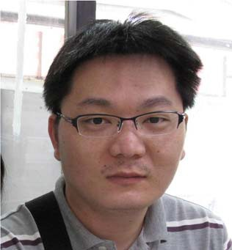
EDUCATIONAL BACKGROUND
Country* | Taiwan
Current Affiliation* | Sports medicine Center, Chang-Gung Memorial Hospital, Chiayi, Taiwan
Areas of Interest* | Molecular biology, Bone metabolism, Sarcopenia, Gait motion analysis
Education | Ph.D.
Post-Graduate Education* | M.S., Biochemistry and Molecular Biology, College of Medicine, National Cheng Kung University  Ph.D. , Graduate Institute of Microbiology, College of Medicine, National Taiwan University
Academic Appointments*

Professional Affiliations and  Scientific Publications* | Scientific Publications :  Twenty-four-week hospital-based progressive resistance training on functional recovery in female patients post total knee arthroplasty. Wei-Hsiu Hsu, Wei-Bin Hsu, Wun-Jer Shen, Zin-Rong Lin, Shr-Hsin Chang, Robert Wen-Wei Hsu (2019, Jun). The knee, 26(3), 729-736.  Comparison of Computer-Assisted Navigation and Conventional Instrumentation for Bilateral TKA: The Outcomes at Mid-Term Follow-up. Robert Wen-Wei Hsu, Wei-Hsiu Hsu , Wun-Jer Shen, Wei-Bin Hsu , Shr-Hsin Chang (2019, Nov)Medicine, 98(47):e18083.  The effects of high impact exercise intervention on bone mineral density, physical fitness, and quality of life in postmenopausal women with osteopenia A retrospective cohort study. Yu, Pei-An; Hsu, Wei-Hsiu; Hsu, Wei-Bin; Kuo, Liang-Tseng; Lin, Zin-Rong; Shen, Wun-Jer ; Hsu, Robert Wen-Wei (2019, Mar). Medicine, 98(11), p e14898.  Transcriptome Analysis of Osteoblast in Ovariectomized Mice in Response to Physical Exercise. Wei-Bin Hsu；Wei-Hsiu Hsu；Ji-Shiuan Hung；Wun-Jer Shen；Robert Wen-Wei Hsu. Bone joint researcch, 2018;7(11): 601–608.  Evaluation of a novel biodegradable thermosensitive keto-hydrogel for improving postoperative pain in a rat model. Wu MH, Shih MH, Hsu WB, Dubey NK, Lee WF, Lin TY, Hsieh MY, Chen CF, Peng KT, Huang TJ, Shi CS, Guo RS, Cai CJ, Chung CY, Wong CH. PLoS One. 2017 Oct 23;12(10):e0186784.  Circuit training enhances function in patients undergoing total knee arthroplasty: a retrospective cohort study. Hsu WH, Hsu WB, Shen WJ, Lin ZR, Chang SH, Hsu RW.  J Orthop Surg Res. 2017 Oct 19;12(1):156.  The Chinese Herbal Mixture Tien-Hsien Liquid Augments the Anticancer Immunity in Tumor Cell-Vaccinated Mice. Yang PM, Du JL, Wang GN, Chia JS, Hsu WB, Pu PC, Sun A, Chiang CP, Wang WB. Integr Cancer Ther. 2017 Sep;16(3):319-328.  Network Signatures of IgG Immune Repertoires in Hepatitis B Associated Chronic  Infection and Vaccination Responses. Chang YH, Kuan HC, Hsieh TC, Ma KH, Yang CH, Hsu WB, Tsai SF, Chao A, Liu HH. Sci Rep. 2016 May 25;6:26556.  Fermentation product of soybean, black bean, and green bean mixture induces apoptosis in a wide variety of cancer cells. Chia Jean-San, Du Jia-Ling, Wu Ming-Shiou, Hsu Wei-Bin, Chiang Chun-Pin,Sun Andy, Lu John Jenn-Yenn, Wang Won –Bo. Integr Cancer Ther. 2013 May;12(3):248-56.  Cellular Protein HAX1 Interacts with the Influenza A Virus PA Polymerase Subunit and Impedes Its Nuclear Translocation. Hsu WB, Shih JL, Shih JR, Du JL, Teng SC, Huang LM, Wang WB. J Virol. 2013 Jan;87(1):110-23.

Invited Speaker’s Name* | Hung-Chih Hsu MD, PhD | 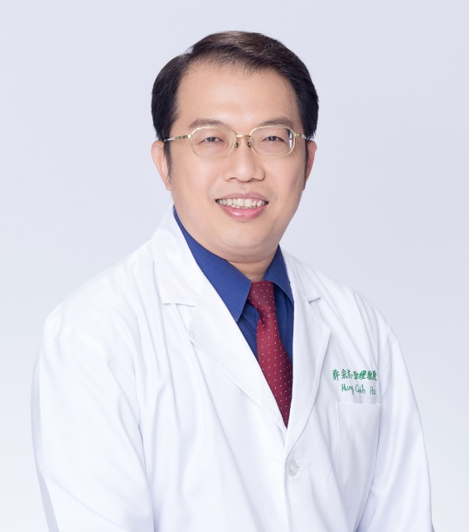
EDUCATIONAL BACKGROUND
Country* | Taiwan, ROC
Current Affiliation* | Attending Physician, Dep of Physical Medicine & Rehabilitation, Chang Gung Memorial Hospital(Chiayi)
Areas of Interest* | Sport Medicine & Sports Injury Rehabilitation,  Regenerative Therapy,  Myofascial Pain Syndrome,  Early Childhood Intervention
Education | MD, Taipei Medical University
Post-Graduate Education* | Ph.D. Graduate Institute of Clinical Medical Sciences, Chang Gung University, Taiwan.
Academic Appointments* | Associate Professor, Department of Medicine, Chang Gung University  Associate Professor, Department of Natureal Biotechnology, Master’s Program in Natural Healing Sciences, Nanhua University.  Associate Professor, Department of Senior Welfare and Services, South Tainan University of Science and Technology
Professional Affiliations and  Scientific Publications* | President, Formosa Green Care Association, Taiwan.  Director, Sports Medicine Association, R.O.C  Director, Taiwan Myopain Society.  Director, Taiwan Taekwondo Sport Society

Invited Speaker’s Summary CV

Invited Speaker’s Summary CV
Invited Speaker’s Name* | 吳致寬 | 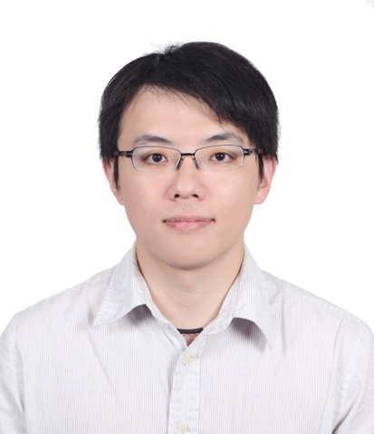
EDUCATIONAL BACKGROUND
Country* | 台灣
Current Affiliation* | 林口長庚復健科主治醫師
Areas of Interest* | 運動醫學、復健醫學
Education | 中山醫學大學醫學系
Post-Graduate Education* | 長庚大學復健科學研究所博士班
Academic Appointments*

Professional Affiliations and  Scientific Publications* | - Chih-Kuan Wu, Shu-Chun Huang, Kuan-Chou Chen, Cheng-Hsiu Lai, Chia-Hua Kuo, Shih-Wei Chou*, 2013 March, Kneeling Leg Curl with Internal Rotation Training Improves Agility in Patients with Anterior-posterior Laxity of Knee, Taiwan Journal of Physical Medicine and Rehabilitation , p21-30  - 張韡瀚*;吳致寬;裴育晟;陳芝琪;黃美涓, 2013 3月,以玻尿酸注射治療足跟脂肪墊症候群：病例報告, 臺灣復健醫學雜誌 , 頁59-67  - Chih-Kuang Chen*, Yu-Cheng Pei, Ning-Hung Chen, Li-Ting Huang, Shih-Wei Chou, Katie P. Wu, Pei-Chih Ko, Alice M.K. Wong, Chih-Kuan Wu, 2014 April, Sedative Music Facilitates Deep Sleep in Young Adults, The Journal of Alternative and Complementary Medicine, p312-317.  - Tang SF, Chen CH, Wu CK, Hong WH, Chen KJ, Chen CK. 2015 Feb. The effects of total contact insole with forefoot medial posting on rearfoot movement and foot pressure distributions in patients with flexible flatfoot. Clin Neurol Neurosurg. Suppl 1:S8-11.  - Tang SF, Wu CK, Chen CH, Chen JT, Tang AC, Wu SH. 2015 Feb. Muscle activation features of the osteoarthritic knee with patellar lateral subluxation. Clin Neurol Neurosurg. 2015 Feb Suppl 1:S30-5  - Tang SF, Chen CP, Lin SC, Wu CK, Chen CK, Cheng SP. 2015 Feb. Reduction of plantar pressures in leprosy patients by using custom made shoes and total contact insoles. Clin Neurol Neurosurg. Suppl 1:S12-5.  - Lin YC, Hsu WC, Wu CK, Chang WH, Wu KP, Wong AM. 2016 Jun. Comparison of motor performance of upper and lower extremities in dual-task tests in patients with mild Alzheimer's dementia. Aging Clin Exp Res. 28(3):491-6

Invited Speaker’s Summary CV
Invited Speaker’s Name* | Yi-Sheng Chan | 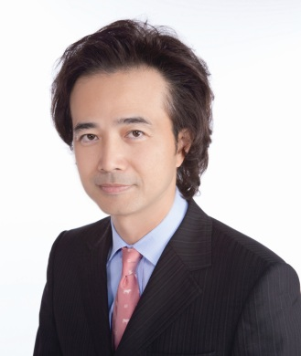
EDUCATIONAL BACKGROUND
Country* | Taiwan, Republic of China
Current Affiliation* | Department of Orthopaedic Surgery, Division of Sports Medicine, Chang Gung Memorial Hospital and Chang Gung University College of Medicin, Taiwan, R.O.C.
Areas of Interest* | - Orthopaedic Sports Medicine & Arthroscopy  - Tissue engineering of muscle and ligament  - Hyperbaric Oxygen Medicine
Education | 1983 - 1990 Medical school course Chung-Shan Medical University
Post-Graduate Education* | 1990 – 1995 Residency in Orthopaedics Chang Gung Memorial Hospital Linkou Medial Center  1997 – 1998 Fellow, Sports Medicine and Knee Arthroscopic Surgery, Director Dr. Ching-Jen Wang, Chang Gung Memorial Hospital, Kaoshuhg  2000 – 2001 Research Fellow, Department of Orthopaedic Surgery,  Director Dr. Freddie H. Fu. Division of Sports Medicine, Musculoskeletal Research Center, University of Pittsburgh
Academic Appointments* | 2018 December Chairman Department of Orthopaedic Surgery  Chang Gung Memorial Hospital and Chang Gung University  2016 -- 2018 President of Taiwan Arthroscopy and Knee Society (TAKS)  2016 July Vice Chairman Department of Orthopaedic Surgery  Chang Gung Memorial Hospital and Chang Gung University  2014 --2016 Secretary General of Taiwan Orthopaedic Association (TOA)  2010 – till now Professor & Chief  Division of Sports Medicine Department of Orthopaedic Surgery  Chang Gung Memorial Hospital and Chang Gung University  2004–till now Committee Board of Taiwan Arthroscopy and Knee Society (TAKS)  2004 Associate Professor
Professional Affiliations and  Scientific Publications* | - American Academy of Orthopaedic Surgeons (AAOS)  - Arthroscopy Association of North America (AANA)  - Orthopaeic Research Society (ORS)  - American Orthopaedic Society for Sports Medicine (AOSSM)  - International Society for Hip Arthroscopy (ISHA)  - Asia-Pacific Knee, Arthroscopy and Sports Medicine Society (APKASS)  - Surgical Association of the Republic of China  - Orthopaedic Association of the Republic of China  - Sports Medicine Association of the Republic of China  - Arthroscopy Association of the Republic of China  - Undersea and Hyperbaric Medical Association of the Republic of China  - Undersea and Hyperbaric Medical Society, U.S.A.  - Taiwan Orthopaedic Research Society  - AO Alumni Member of AO Alumni Association  104 publications in the peer-review journals and 20 National Science Research and hospital Projects finished or in progress.

唐浩哲(cv)
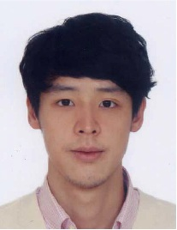
研究領域:
- 分子及細胞生物學
- 骨科學
工作經歷:
- 基隆長庚紀念醫院骨科住院醫師
- 基隆長庚紀念醫院骨科總醫師
- 林口長庚運動醫學骨科研究員
- 基隆長庚骨科部運動醫學及外傷骨科主治醫師
學歷:
長庚大學醫學系
代表論文:
- Tang HC, Lee WC, Kao HK, Yang WE, Chang CH. Surgical Outcomes of Developmental Dysplasia of the Hip With or Without Prior Failed Closed Reduction. J PediatrOrthop. 2015 Oct-Nov;35(7):703-7.
- Tang HC, Chen WC, Chiang CW, Chen LY, Chang YC, Chen CH. Differentiation Effects of Platelet-Rich Plasma Concentrations on Synovial Fluid Mesenchymal Stem Cells from Pigs Cultivated in Alginate Complex Hydrogel. Int J Mol Sci. 2015 Aug 7;16(8):18507-21.
- Tang HC, Chen IJ, Yeh YC, Weng CJ, Chang SS, Chen AC, Chan YS. Correlation of parameters on preoperative CT images with intra-articular soft-tissue injuries in acutetibial plateau fractures: A review of 132 patients receiving ARIF. Injury. 2017 Mar;48(3):745-750.
學會與認證:
中華民國骨科醫學會

Invited Speaker’s Summary CV
Invited Speaker’s Name* | Po-Cheng Chen | 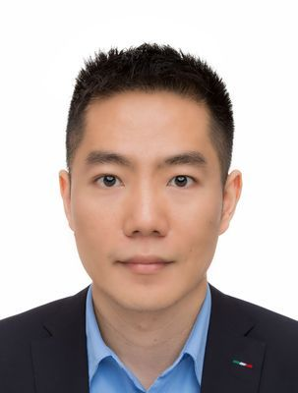
EDUCATIONAL BACKGROUND
Country* | Taiwan
Current Affiliation* | - Department of Physical Medicine and Rehabilitation, Kaohsiung Municipal Feng-Shan Hospital, Kaohsiung, Taiwan  - Department of Physical Medicine and Rehabilitation, Kaohsiung Chang Gung Memorial Hospital, Kaohsiung, Taiwan
Areas of Interest* | Sports medicine, rehabilitation, ultrasound, evidence-based medicine.
Education | 2004/09~2011/06, Chang Gung University, College of Medicine, Taoyuan, Taiwan.
Post-Graduate Education* | 2019/09~ National Cheng Kung University, College of Medicine, Department of Public Health.
Academic Appointments* | Lecturer of Chang Gung Memorial Hospital.
Professional Affiliations and  Scientific Publications* | - Chen PC, Chuang CH, Tu YK, Bai CH, Chen CF, Liaw MY. A Bayesian network meta-analysis: Comparing the clinical effectiveness of local corticosteroid injections using different treatment strategies for carpal tunnel syndrome. BMC Musculoskelet Disord. 2015;16:363. (SCI；IF=1.879；Orthopedics 44/82)  - Chen PC, Chuang CH, Leong CP, Guo SE, Hsin YJ. Systematic review and meta-analysis of the diagnostic accuracy of the water swallow test for screening aspiration in stroke patients. J Adv Nurs 2016, 72(11):2575-2586. (SCI；IF=2.561；Nursing 6/123)  - Chen PC, Liaw MY, Wang LY, Tsai YC, Hsin YJ, Chen YC, Chen SM, Lin MC. Inspiratory muscle training in stroke patients with congestive heart failure: A CONSORT-compliant prospective randomized single-blind controlled trial. Medicine(Baltimore) 2016;95:e4856. (SCI；IF=1.552；Medicine, General & Internal 89/165)  - Chen PC, Wang LY, Pong YP, Hsin YJ, Liaw MY, Chiang CW. Effectiveness of ultrasound-guided vs direct approach corticosteroid injections for carpal tunnel syndrome: A double-blind randomized controlled trial. J Rehabil Med 2018, 50(2):200-208. (SCI；IF=2.046；Rehabilitation 20/68)  - Chuang CH, Chen CH, Bai CH, Chen PC, Wu SC, Liu CH. Risk factors associated with newly psychiatric disorder in spinal cord injury: A retrospective cohort study. J Clin Nurs 2018, 27(5-6):e1038-e1047. (SCI；IF=1.972；Nursing 23/123)  - Cheng BC, Chen PC, Chen PC, Lu CH, Huang YC, Chou KH, Li SH, Lin AN, Lin WC. Decreased cerebral blood flow and improved cognitive function in patients with end-stage renal disease after peritoneal dialysis: An arterial spin-labelling study. Eur Radiol 2018, 29(3):1415-1424. (SCI；IF=4.101；Radiology, Nuclear Medicine & Medical Imaging 21/133)  - Lee YY, Yang TH, Huang CC, Huang YC, Chen PC, Hsu CH, Wang LY, Chou WY. Ultrasonography has high positive predictive value for medial epicondyle lesions among adolescent baseball players. Knee Surg Sports Traumatol Arthrosc 2018, in press. (SCI；IF=3.166；Orthopedic 15/82)  - Chuang CH, Chen PC, Lee CS, Chen CH, Tu YK, Wu SC. Music Intervention for Pain and Anxiety Management of the Primiparous Women During Labour: A Systematic Review and Meta-Analysis. J Adv Nurs 2018, 75(4):723-733. (SCI；IF=2.561；Nursing 6/123)  - Yang TH, Lee YY, Huang CC, Huang YC, Chen PC, Hsu CH, Wang LY, Chou WY. Effectiveness of ultrasonography screening and risk factor analysis of capitellar osteochondritis dissecans in adolescent baseball players. J Shoulder Elbow Surg 2018, 27(11):2038-2044. (SCI；IF=2.817；Orthopedic 20/82)  - Wu KT, Chou WY, Wang CJ, Chen CY, Ko JY, Chen PC, Cheng JH, Yang YJ. Efficacy of Extracorporeal Shockwave Therapy on Calcified and Noncalcified Shoulder Tendinosis: A Propensity Score Matched Analysis. Biomed Res Int 2019:2958251. (SCI；IF=2.276；Biotechnology & applied microbiology 92/156)  - Huang YC, Chen PC, Tso HH, Yang YC, Ho TL, Leong CP. Effects of kinesio taping on hemiplegic hand in patients with upper limb post-stroke spasticity: a randomized controlled pilot study. Eur J Phys Rehabil Med 2019,55(5):551-557. (SCI；IF=2.258；Rehabilitation 15/68)  - Huang YC, Lee YY, Tso HH, Chen PC, Chen YC, Chien CY, Chung YJ, Leong CP. The Sonography and Physical Findings on Shoulder after Selective Neck Dissection in Patients with Head and Neck Cancer: A Pilot Study. Biomed Res Int 2019:2528492. (SCI；IF=2.276；Biotechnology & applied microbiology 92/156)  - Chen PC, Wu KT, Chou WY, Huang YC, Wang LY, Yang TH, Siu KK, Tu YK. Comparative Effectiveness of Different Nonsurgical Treatments for Patellar Tendinopathy: A Systematic Review and Network Meta-analysis. Arthroscopy. 2019, 35(11):3117-3131.e2. (SCI；IF=4.325；Orthopedics 6/82)  - Lin WC, Huang YC, Leong CP, Chen MH, Chen HL, Tsai NW, Tso HH, Chen PC, Lu CH. Associations Between Cognitive Functions and Physical Frailty in Patients With Parkinson's Disease. Front Aging Neurosci. 2019,11:283. (SCI；IF=4.362；Geriatrics & Gerontology 9/51)  - Kuo CA, Wu SY, Lee CH, Lai YR, Lu CH, Chen PC, Cheng JH, Tsai LY, Yen KT, Tsao Y, Tsai SM. Toona sinensis modulates autophagy and cytokines in lipopolysaccharide-induced RAW 264.7 macrophages. Biomed. Pharmacother. 2020, 129: 110386. (SCI；IF=4.545；Pharmacology & Pharmacy 42/270)  - Tseng YH, Chou WY, Wu KT, Chang CD, Chen YC, Huang YC, Lin WC, Chen PC. Use sonoelastography to predict the reparability of large-to-massive rotator cuff tears. Medicine. 2020, 99(27):e21139. (SCI；IF=1.552；Medicine, General & Internal 89/165)  - Cheng KL, Lin LH, Chen PC, Chiang PL, Chen YS, Chen HL, Chen MH, Chou KH, Li SH, Lu CH, Lin WC. Reduced Gray Matter Volume and Risk of Falls in Parkinson’s Disease with Dementia Patients: A Voxel-Based Morphometry Study. Int. J. Environ. Res. Public Health. 2020, 17(15): 5374. (SCI；IF= 2.468；Public, Environmental & Occupational health 32/170)  - Lu YT, Chen PC, Huang YH, Huang FC. Making a decision between acute appendicitis and acute gastroenteritis. Children 2020, 7(10):176. (SCI；IF=2.078；Pediatrics 50/128)

Invited Speaker’s Summary CV
Invited Speaker’s Name* | Kuan-Ting Wu | 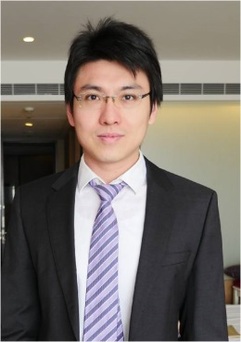
EDUCATIONAL BACKGROUND
Country* | Taiwan, Republic of China
Current Affiliation* | Kaohsiung Chang Gung Memorial Hospital
Areas of Interest* | Knee, shoulder, elbow, wrist arthroscopy and reconstruction, orthopaedic trauma, Sports related injury
Education | Chang Gung university, Department of medicine
Post-Graduate Education* | - 2011-2012 Kaohsiung Chang Gung memorial hospital  Post-Graduated year training  - 2012-2017 Kaohsiung Chang Gung memorial hospital,  Department of orthopaedic surgery, Resident  - 2017-present Kaohsiung Chang Gung memorial hospital,  Department of orthopaedic surgery, attending physician
Academic Appointments* | Lecturer
Professional Affiliations and  Scientific Publications* | - Isolated revision of the acetabular component using alumina-on-alumina bearings without a metal sleeve: A preliminary study Wu KT, Wang JW*, Lu YD, Yen SH, Lee MS  J of Orthopaedic Surgery 2017;25(2):721041  2. The incidence and risk factors of acute kidney disease after total knee Arthroplasty with early postoperative volume supplement Wu KT(Co-first), Chen CY, Chen B, Wang JW*, Lin PC, Yen SH. Biomed Research International 2018;2018:8718545  3. Relationship between the social support and self-efficacy for function ability in patients undergoing primary hip replacement  Wu KT(Co-first), Lee PS, Chou WY*, Chen SH, Huang YT  J of Orthop Surg & Res 2018;13:150  4. Efficacy of Extracorporeal Shockwave Therapy on Calcified and Noncalcified Shoulder Tendinosis: A Propensity Score Matched Analysis  Wu KT, Chou WY, Wang CJ, Chen CY, Ko JY, Chen PC  Biomed Research International 2019;2019: 2958251.  5. Inferior outcome of rotator cuff repair in chronic hemodialytic patients  Wu KT, Chou WY, Ko JY, Siu KK  BMC Musculoskeletal Disorders 2019: 20:209  6. Comparative Effectiveness of Different Nonsurgical Treatments for Patellar Tendinopathy: A Systematic Review and Network Meta-analysis Chen PC, Wu KT(Co-first), Chou WY; Arthroscopy 2019;35(11): 3117

Invited Speaker’s Summary CV
Invited Speaker’s Name* | Po-Cheng Chen
EDUCATIONAL BACKGROUND
Country* | Taiwan
Current Affiliation* | - Department of Physical Medicine and Rehabilitation, Kaohsiung Municipal Feng-Shan Hospital, Kaohsiung, Taiwan  - Department of Physical Medicine and Rehabilitation, Kaohsiung Chang Gung Memorial Hospital, Kaohsiung, Taiwan
Areas of Interest* | Sports medicine, rehabilitation, ultrasound, evidence-based medicine.
Education | 2004/09~2011/06, Chang Gung University, College of Medicine, Taoyuan, Taiwan.
Post-Graduate Education* | 2019/09~ National Cheng Kung University, College of Medicine, Department of Public Health.
Academic Appointments* | Lecturer of Chang Gung Memorial Hospital.
Professional Affiliations and  Scientific Publications* | - Chen PC, Chuang CH, Tu YK, Bai CH, Chen CF, Liaw MY. A Bayesian network meta-analysis: Comparing the clinical effectiveness of local corticosteroid injections using different treatment strategies for carpal tunnel syndrome. BMC Musculoskelet Disord. 2015;16:363. (SCI；IF=1.879；Orthopedics 44/82)  - Chen PC, Chuang CH, Leong CP, Guo SE, Hsin YJ. Systematic review and meta-analysis of the diagnostic accuracy of the water swallow test for screening aspiration in stroke patients. J Adv Nurs 2016, 72(11):2575-2586. (SCI；IF=2.561；Nursing 6/123)  - Chen PC, Liaw MY, Wang LY, Tsai YC, Hsin YJ, Chen YC, Chen SM, Lin MC. Inspiratory muscle training in stroke patients with congestive heart failure: A CONSORT-compliant prospective randomized single-blind controlled trial. Medicine(Baltimore) 2016;95:e4856. (SCI；IF=1.552；Medicine, General & Internal 89/165)  - Chen PC, Wang LY, Pong YP, Hsin YJ, Liaw MY, Chiang CW. Effectiveness of ultrasound-guided vs direct approach corticosteroid injections for carpal tunnel syndrome: A double-blind randomized controlled trial. J Rehabil Med 2018, 50(2):200-208. (SCI；IF=2.046；Rehabilitation 20/68)  - Chuang CH, Chen CH, Bai CH, Chen PC, Wu SC, Liu CH. Risk factors associated with newly psychiatric disorder in spinal cord injury: A retrospective cohort study. J Clin Nurs 2018, 27(5-6):e1038-e1047. (SCI；IF=1.972；Nursing 23/123)  - Cheng BC, Chen PC, Chen PC, Lu CH, Huang YC, Chou KH, Li SH, Lin AN, Lin WC. Decreased cerebral blood flow and improved cognitive function in patients with end-stage renal disease after peritoneal dialysis: An arterial spin-labelling study. Eur Radiol 2018, 29(3):1415-1424. (SCI；IF=4.101；Radiology, Nuclear Medicine & Medical Imaging 21/133)  - Lee YY, Yang TH, Huang CC, Huang YC, Chen PC, Hsu CH, Wang LY, Chou WY. Ultrasonography has high positive predictive value for medial epicondyle lesions among adolescent baseball players. Knee Surg Sports Traumatol Arthrosc 2018, in press. (SCI；IF=3.166；Orthopedic 15/82)  - Chuang CH, Chen PC, Lee CS, Chen CH, Tu YK, Wu SC. Music Intervention for Pain and Anxiety Management of the Primiparous Women During Labour: A Systematic Review and Meta-Analysis. J Adv Nurs 2018, 75(4):723-733. (SCI；IF=2.561；Nursing 6/123)  - Yang TH, Lee YY, Huang CC, Huang YC, Chen PC, Hsu CH, Wang LY, Chou WY. Effectiveness of ultrasonography screening and risk factor analysis of capitellar osteochondritis dissecans in adolescent baseball players. J Shoulder Elbow Surg 2018, 27(11):2038-2044. (SCI；IF=2.817；Orthopedic 20/82)  - Wu KT, Chou WY, Wang CJ, Chen CY, Ko JY, Chen PC, Cheng JH, Yang YJ. Efficacy of Extracorporeal Shockwave Therapy on Calcified and Noncalcified Shoulder Tendinosis: A Propensity Score Matched Analysis. Biomed Res Int 2019:2958251. (SCI；IF=2.276；Biotechnology & applied microbiology 92/156)  - Huang YC, Chen PC, Tso HH, Yang YC, Ho TL, Leong CP. Effects of kinesio taping on hemiplegic hand in patients with upper limb post-stroke spasticity: a randomized controlled pilot study. Eur J Phys Rehabil Med 2019,55(5):551-557. (SCI；IF=2.258；Rehabilitation 15/68)  - Huang YC, Lee YY, Tso HH, Chen PC, Chen YC, Chien CY, Chung YJ, Leong CP. The Sonography and Physical Findings on Shoulder after Selective Neck Dissection in Patients with Head and Neck Cancer: A Pilot Study. Biomed Res Int 2019:2528492. (SCI；IF=2.276；Biotechnology & applied microbiology 92/156)  - Chen PC, Wu KT, Chou WY, Huang YC, Wang LY, Yang TH, Siu KK, Tu YK. Comparative Effectiveness of Different Nonsurgical Treatments for Patellar Tendinopathy: A Systematic Review and Network Meta-analysis. Arthroscopy. 2019, 35(11):3117-3131.e2. (SCI；IF=4.325；Orthopedics 6/82)  - Lin WC, Huang YC, Leong CP, Chen MH, Chen HL, Tsai NW, Tso HH, Chen PC, Lu CH. Associations Between Cognitive Functions and Physical Frailty in Patients With Parkinson's Disease. Front Aging Neurosci. 2019,11:283. (SCI；IF=4.362；Geriatrics & Gerontology 9/51)  - Kuo CA, Wu SY, Lee CH, Lai YR, Lu CH, Chen PC, Cheng JH, Tsai LY, Yen KT, Tsao Y, Tsai SM. Toona sinensis modulates autophagy and cytokines in lipopolysaccharide-induced RAW 264.7 macrophages. Biomed. Pharmacother. 2020, 129: 110386. (SCI；IF=4.545；Pharmacology & Pharmacy 42/270)  - Tseng YH, Chou WY, Wu KT, Chang CD, Chen YC, Huang YC, Lin WC, Chen PC. Use sonoelastography to predict the reparability of large-to-massive rotator cuff tears. Medicine. 2020, 99(27):e21139. (SCI；IF=1.552；Medicine, General & Internal 89/165)  - Cheng KL, Lin LH, Chen PC, Chiang PL, Chen YS, Chen HL, Chen MH, Chou KH, Li SH, Lu CH, Lin WC. Reduced Gray Matter Volume and Risk of Falls in Parkinson’s Disease with Dementia Patients: A Voxel-Based Morphometry Study. Int. J. Environ. Res. Public Health. 2020, 17(15): 5374. (SCI；IF= 2.468；Public, Environmental & Occupational health 32/170)  - Lu YT, Chen PC, Huang YH, Huang FC. Making a decision between acute appendicitis and acute gastroenteritis. Children 2020, 7(10):176. (SCI；IF=2.078；Pediatrics 50/128)

Invited Speaker’s Summary CV
Invited Speaker’s Name* | Kuan-Ting Wu
EDUCATIONAL BACKGROUND
Country* | Taiwan, Republic of China
Current Affiliation* | Kaohsiung Chang Gung Memorial Hospital
Areas of Interest* | Knee, shoulder, elbow, wrist arthroscopy and reconstruction, orthopaedic trauma, Sports related injury
Education | Chang Gung university, Department of medicine
Post-Graduate Education* | - 2011-2012 Kaohsiung Chang Gung memorial hospital  Post-Graduated year training  - 2012-2017 Kaohsiung Chang Gung memorial hospital,  Department of orthopaedic surgery, Resident  - 2017-present Kaohsiung Chang Gung memorial hospital,  Department of orthopaedic surgery, attending physician
Academic Appointments* | Lecturer
Professional Affiliations and  Scientific Publications* | - Isolated revision of the acetabular component using alumina-on-alumina bearings without a metal sleeve: A preliminary study Wu KT, Wang JW*, Lu YD, Yen SH, Lee MS  J of Orthopaedic Surgery 2017;25(2):721041  2. The incidence and risk factors of acute kidney disease after total knee Arthroplasty with early postoperative volume supplement Wu KT(Co-first), Chen CY, Chen B, Wang JW*, Lin PC, Yen SH. Biomed Research International 2018;2018:8718545  3. Relationship between the social support and self-efficacy for function ability in patients undergoing primary hip replacement  Wu KT(Co-first), Lee PS, Chou WY*, Chen SH, Huang YT  J of Orthop Surg & Res 2018;13:150  4. Efficacy of Extracorporeal Shockwave Therapy on Calcified and Noncalcified Shoulder Tendinosis: A Propensity Score Matched Analysis  Wu KT, Chou WY, Wang CJ, Chen CY, Ko JY, Chen PC  Biomed Research International 2019;2019: 2958251.  5. Inferior outcome of rotator cuff repair in chronic hemodialytic patients  Wu KT, Chou WY, Ko JY, Siu KK  BMC Musculoskeletal Disorders 2019: 20:209  6. Comparative Effectiveness of Different Nonsurgical Treatments for Patellar Tendinopathy: A Systematic Review and Network Meta-analysis Chen PC, Wu KT(Co-first), Chou WY; Arthroscopy 2019;35(11): 3117

Invited Speaker’s Summary CV
Invited Speaker’s Name* | 王琳毅; Wang, Lin-Yi | 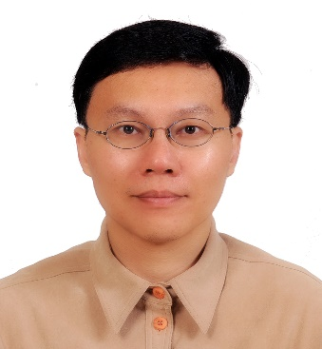
EDUCATIONAL BACKGROUND
Country* | Taiwan, R.O.C.
Current Affiliation* | Department of Physical Medicine and Rehabilitation, Kaohsiung Chang Gung Memorial Hospital
Areas of Interest* | Musculoskeletal Sonography; Sports Medicine; Cardiac Rehabilitation; Peripheral Nerve System Disorder
Education | 1991-1998, Department of Medicine, National Yang-Ming University, Taipei City
Post-Graduate Education* | Nil
Academic Appointments* | 2013-2015, Adjunct lecturer, Meical Mechatronic Engineering Program,  Cheng-Shiu University
Professional Affiliations and  Scientific Publications* | 1. 1998-2002, Resident, Department of Physical Medicine and Rehabilitation, Chang-Gung Memorial Hospital, Kaohsiung.  2. 2002-present, Attending Physiatrist, Department of Physical Medicine and Rehabilitation, Kaohsiung Chang Gung Memorial Hospital.  3. 2013-2020, Chief, Department of Physical Medicine and Rehabilitation, Kaohsiung Chang Gung Memorial Hospital.  4. 2003, Attending Physiatrist, Department of Physical Medicine and Rehabilitation, Taitung Christian Hospital, Taitung.  - Wang LY*. Pong YP. Wang HC. Su SH. Tsai CH. Leong CP. Cumulative trauma disorders in betel pepper leaf-cullers visiting a rehabilitation clinic: experience in Taitung. Chang Gung Medical Journal. 2005; 28(4):237-46.  - Wang LY. Leong CP. Huang YC. Hung JW. Cheung SM. Pong YP＊. Best diagnostic criterion in high-resolution ultrasonography for carpal tunnel syndrome. Chang Gung Medical Journal. 2008; 31(5):469-76.  - Wang LY. Pong YP. Huang YC*. Leong CP. Liaw MY. Chen HY. Sonography and physical findings in stroke patients with hemiplegic shoulders: a longitudinal study. Journal of Rehabilitation Medicine. 2012; 44(7):553-7. (SCI；IF=2.046；Rehabilitation 20/68)  - Wang LY, Liaw MY*, Huang YC, Lau YC, Leong CP, Pong YP, Chen CL. Static and dynamic balance performance in patients with osteoporotic vertebral compression fracture. Journal of Back and Musculoskeletal Rehabilitation. 2013; 26(2):199-205. (SCI；IF=0.821；Rehabilitation 63/68)  - Wang LY, Li JY, Huang YC, Liaw, MY Yang TH, Hsin YJ, Lee W, Chang JK, Pong YP*. The Utility of Semmes-Weinstein Monofilament Tests in Detecting Carpal Tunnel Syndrome with Clinical Stage, Nerve Conduction Study, and Sonography Correlations. Taiwan Journal of Physical Medicine and Rehabilitation. 2015; 43 (1):9-18.  - Wang LY, Liaw MY, Huang YC, Chen HL, Lau YC, Pong YP. The Use of Ultrasonography to Assess Outcomes and Prognostic Indicators in Carpal Tunnel Syndrome: A Study in Patients Treated with Night Splinting. Taiwan Journal of Physical Medicine and Rehabilitation. 2016; 44(3):123-34  - Yang TH, Huang YC, Lau YC, Wang LY*. Efficacy of Radial Extracorporeal Shock Wave Therapy on Lateral Epicondylosis, and Changes in the Common Extensor Tendon Stiffness with Pretherapy and Posttherapy in Real-Time Sonoelastography: A Randomized Controlled Study. American Journal of Physical Medicine & Rehabilitation. 2017; 96(2):93-100. (SCI; IF=1.838; Rehabilitation 26/68)  - Wang LY, Yang TH, Huang YC, Chou WY, Huang CC*, Wang CJ*. Evaluating Posterior Cruciate Ligament Injury by Using Two-dimensional Ultrasonography and Sonoelastography. Knee Surgery Sports Traumatology Arthroscopy 2017; 25(10):3108-15. (SCI; IF=3.149; Sports Sciences 14/83)  - Wang LY, Chen PC, Pong YP*, Hsin YJ, Liaw MY, Chiang CW. Effectiveness of ultrasound-guided vs direct approach corticosteroid injections for carpal tunnel syndrome: A double-blind randomized controlled trial. Journal of Rehabilitation Medicine 2018; 50(2):200-208. (SCI；IF=2.046；Rehabilitation 20/68)  - Yang TH, Lee YY, Huang CC, Huang YC, Chen PC, Hsu CH, Wang LY*, Chou WY*. Effectiveness of Ultrasonographic Screening and Risk Factor Analysis of Capitellar Osteochondritis Dissecans in Adolescent Baseball Players. Journal of Shoulder and Elbow Surgery 2018;27(11):2038-44 (SCI; IF=2.865; Sports Science 19/83)  - Lee YY, Yang TH, Huang CC, Huang YC, Chen PC, Hsu CH, Wang LY*, Chou WY*, Ultrasonography Has High Positive Predictive Value for Medial Epicondyle Lesions Among Adolescent Baseball Players. Knee Surgery Sports Traumatology Arthroscopy 2019;27(10):3261-8 (SCI; IF=3.149; Sports Sciences 14/83)

Invited Speaker’s Summary CV
Invited Speaker’s Name* | SHUN-WUN, JHAN | 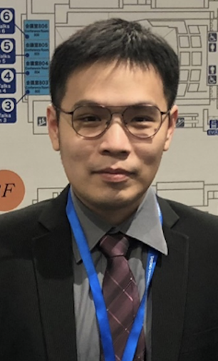
EDUCATIONAL BACKGROUND
Country* | Taiwan
Current Affiliation* | Kaohsiung Chang Gung memorial hospital  Attending in orthopaedic department
Areas of Interest* | Sports medicine; Arthroscopic surgery (shoulder, knee and hip)
Education | Chang Gung university, Department of medicine
Post-Graduate Education* | 2015/08 Orthopedic Resident Training course  2015/10 Extracorporeal Shock Wave Therapy Training course  2015/10 AOTrauma course – Basic principles of Fracture Management  2016/01 Pediatric Orthopedics Training Course  2016/08 Pan Asia Orthopedic trauma symposium  2017/08 Trauma Decision Making Workshop  Pan Asia Orthopedic trauma symposium  2017/10 Advanced Cadaveric course- TOTA Trauma Surgery Workshop  2018/04 Trauma Resident Training course  2018/11 Advanced Cadaveric course- TOTA Trauma Surgery Workshop  2019/01 Pediatric Orthopedics Training Course  2019/03 Cadaveric course- Knee arthroscopy  2019/07 Cadaveric course- Hip arthroscopy  2019/11-2020/01 Fellowship training in LinKou CGMH- hip arthroscopy  2020/09 AO Trauma Masters Course- osteotomy
Academic Appointments* | Lecturer, Department of Orthopaedic Surgery,  Kaohsiung Chang Gung Memorial Hospital
Professional Affiliations and  Scientific Publications* | 1. The risk factors of failed reimplantation arthroplasty for periprosthetic hip infection  Shun-Wun Jhan, Yu-Der Lu, Mel S. Lee, Chen-Hsiang Lee, Jun-Wen Wang and Feng-Chih Kuo *  BMC Musculoskeletal Disorders (2017) 18:255  2. Outcomes and factors of elbow arthroscopy upon returning to sports for throwing athletes with osteoarthritis  Shun-Wun Jhan, Wen-Yi Chou* , Kuan-Ting Wu, Ching-Jen Wang, Ya-Ju Yang and Jih-Yang Ko  Journal of Orthopaedic Surgery and Research (2018) 13:280

Invited Speaker’s Summary CV
Invited Speaker’s Name* | Chun-Jui Weng | 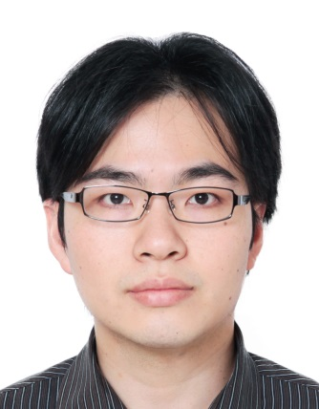
EDUCATIONAL BACKGROUND
Country* | Taiwan, Republic of China
Current Affiliation* | Department of Orthopaedic Surgery, Division of Sports Medicine, Chang Gung Memorial Hospital, Taiwan, R.O.C.
Areas of Interest* | - Orthopaedic Sports Medicine & Arthroscopy  - Orthopaedic Traumatology
Education | 2001 - 2007 Medical school course National Taiwan University
Post-Graduate Education* | 2009 – 2014 Residency in Orthopaedics Chang Gung Memorial Hospital Linkou Medial Center  2014 – 2015 Fellow, Sports Medicine, Chang Gung Memorial Hospital, LinKou
Academic Appointments* | 2016 – till now Attending Physician  Division of Sports Medicine  Department of Orthopaedic Surgery  Chang Gung Memorial Hospital
Professional Affiliations and  Scientific Publications* | - Orthopaedic Association of the Republic of China  - Taiwan Arthroscopy and Knee Society  - Taiwan Shoulder and Elbow Society

Invited Speaker’s Summary CV
Invited Speaker’s Name* | Jen-Hung, Chen (陳仁宏) | 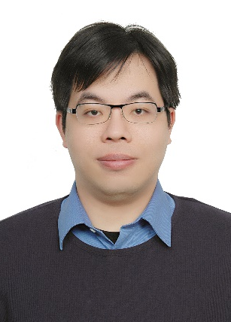
EDUCATIONAL BACKGROUND
Country* | Taiwan, R.O.C
Current Affiliation* | Chang-Gung Memorial Hospital, Kaohsiung
Areas of Interest* | Orthopaedic Surgery, Orthopaedic Sports medicine,  Foot and Ankle Surgery
Education | Bachelor, Kaohsiung Medical University, Kaohsiung
Post-Graduate Education* | nil
Academic Appointments* | Assistant Professor, Department of Orthopaedic Surgery,  Kaohsiung Chang Gung Memorial Hospital
Professional Affiliations and  Scientific Publications* | - Total Knee Arthroplasty in Patients with Dialysis – A Report of 90-day Complications and Mortality  Chen JH, Kuo FC, Wang JW*  Biomedical J 2014;37(2):84-89. (SCI: IF=1.723; BIOCHEMISTRY & MOLECULAR BIOLOGY 235/292)  2. Functional outcomes of Y-graft double-bundle and single-bundle anterior cruciate ligament reconstruction of the knee  Liu ML, Chen JH, Wang CJ*, Siu KK  Arthroscopy 2013; 29:1525-32. (SCI: IF=4.330; Orthopedics 5/77)  3. Extracorporeal shockwave therapy in osteoporotic osteoarthritis of the knee in rats: an experiement in animals  Wang CJ*, Huang CY, Hsu SL, Chen JH, Cheng JH  Arthritis Research & Therapy 2014; 6:R139 (SCI: IF=4.269; Rheumatology 8/31)  4. Changes of articular cartilage and subchondral bone after extracorporeal shockwave therapy in osteoarthritis of the knee  Wang CJ*, Cheng JH, Chou WY, Hsu SL, Chen JH, Huang CY  Int J Med Sci 2017;14:213-223.(SCI: IF=2.284; MEDICINE, GENERAL & INTERNAL 46/154)  5. Perioperative complications of total knee Arthroplasty in dialysis patients  Yen SH, Chen JH, Lu YD, Wang JW*  J of Arthroplasty 2018;33:872-7. (SCI: IF=3.338; Orthopedics 9/77)  6. High power Doppler ultrasound score is associated with the risk of triangular fibrocartilage complex (TFCC) tears in severe rheumatoid arthritis  Chen JH, Huang KC, Huang CC, Lai HM, Chou WY, Chen YC*  J Investig Med 2018 in press (SCI: IF=2.209; MEDICINE, GENERAL & INTERNAL 55/154)

Invited Speaker’s Summary CV
Invited Speaker’s Name* | 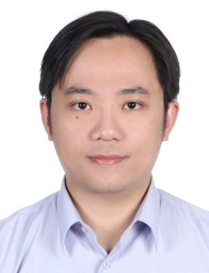  Shih-Sheng Chang
EDUCATIONAL BACKGROUND
Country* | Taiwan, Republic of China
Current Affiliation* | Department of Orthopaedic Surgery, Division of Sports Medicine, Chang Gung Memorial Hospital, Taiwan, R.O.C.
Areas of Interest* | - Orthopaedic Sports Medicine & Arthroscopy  - Orthopaedic Traumatology
Education | 1994/09-2001/06 Kaohsiung Medical University, Kaohsiung, Taiwan
Post-Graduate Education* | 8/2012 ~ 7/2013 Research Fellow, Department of Orthopaedic Surgery, Division of Sports Medicine, Musculoskeletal Research Center, University of Pittsburgh Medical Center  2007/07/01~now Attending Physian, Division of Sports Medicine, Taoyuan Branc, Orthopaedic Department Chang Gung Memorial Hospital Taipei-Linkou Medical Center  2006/07/01~2007/06/30, Fellow, Division of Sports Medicine, Orthopaedic Department Chang Gung Memorial Hospital Taipei-Linkou Medical Center  2002/07/01~2006/06/30, Resident (R2,R3,R4,R5) Orthopaedic Department Chang Gung Memorial Hospital Taipei-Linkou Medical Center  2001/07/01~2002/06/30, Resident (R1) Surgical Department Chang-Gung Memorial Hospital Taipei-Linkou Medical Center
Academic Appointments* | 2007 – till now Attending Physician  Division of Sports Medicine  Department of Orthopaedic Surgery  Chang Gung Memorial Hospital
Professional Affiliations and  Scientific Publications* | - Orthopaedic Association of the Republic of China  - Taiwan Arthroscopy and Knee Society  - Taiwan Shoulder and Elbow Society

Invited Speaker’s Name* | Alvin Chao-Yu Chen, M.D. | 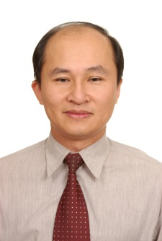
EDUCATIONAL BACKGROUND
Country* | Taiwan, Republic of China
Current Affiliation* | Chief, Department of Orthopaedic Surgery. Taoyuan Chang Gung Memorial Hospital and Chang Gung University College of Medicine, Taiwan, R.O.C.
Areas of Interest* | - Knee Reconstruction  - Shoulder Reconstruction  - Sports Medicine and Arthroscopic Surgery  - Hand and Elbow Surgery
Education | China Medical College (1981-1988), Taichung, Taiwan
Post-Graduate Education* | - General Surgery: Surgical Resident in Chang Gung Memorial Hospital, Taiwan  - Orthopedic Surgery: Orthopedic Resident in Chang Gung Memorial Hospital, Taiwan  - Research Fellow, Massachusetts General Hospital, Orthopaedic Department, Hand and Upper Extremity Service
Academic Appointments* | Associate Professor, Chang Gung University Medical Center
Professional Affiliations | President, Taiwan Society for Surgery of the Hand, 2010/6~2012/5  AOTrauma Asian Pacific Board and Country Council  Taiwan Shoulder and Elbow Society

Invited Speaker’s Summary CV

